Taylor Karriker

Bill McMullin Clinic, October 21-22
.
This week, I had the opportunity to ride with Bill McMullin with my 15-year-old Danish Warmblood, “Z.” It was an incredibly informative experience from which we learned many ways to address our problem areas and gained valuable instruction to work on at home to continue progressing. It was wonderful working with Bill with his insight as a coach as well as a judge.
A broad issue that Z and I have been working through is his nervousness at new facilities. We are currently showing Prix St. Georges and working toward Intermediaire I, but performing collected canter pirouettes in competition has been challenging. Z has a remarkable ability to sit and carry weight on his hind end, but when he becomes tense and I ask for a pirouette, he can sit too much and fall inward. This makes it difficult to exit the pirouette and often results in an unauthorized flying change, particularly in our right pirouette. When I shared this with Bill, he suggested several helpful exercises and concepts.
The first idea he emphasized was the timing of half halts in the canter. Bill explained that a rider has the most influence over the horse’s balance when the front legs are off the ground. Timing the half halt at this point encourages the horse to stay lighter in the forehand and more active behind. He also reminded me how much my position affects Z’s balance and made me think about stretching my ribcage up, bringing my shoulders back and down, and maintaining a steady, supportive seat that invites the hind legs to stay under me.
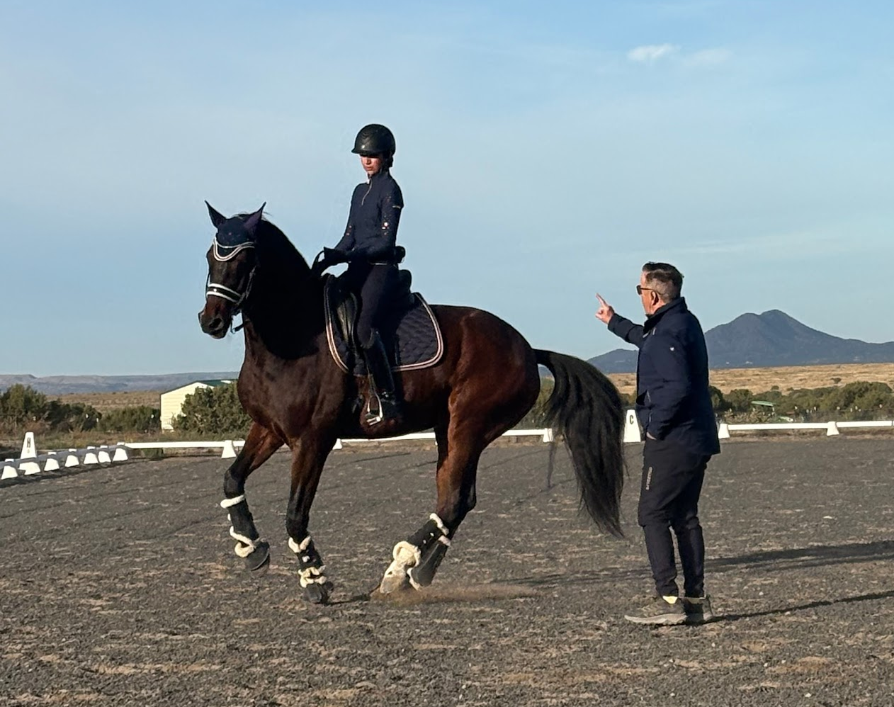
Once we improved the balance of Z’s canter, we started an exercise that can be used in all three gaits: riding a few steps of half pass off the track, then leg yielding back to the track without changing the bend or shape. This helped me gain better control of Z’s shoulders, keep him upright, and improve his responsiveness to my aids. After practicing both directions, we moved to a second exercise specifically focused on the canter pirouettes.
We began on a 10 meter circle in canter, starting canter-walk-canter transitions and transitions within the gait to make sure Z stayed engaged and collected. From there, we performed two to three strides of pirouette before exiting for several strides and then returning to the pirouette. This quick entry and exit exercise helped us maintain activity in the hind leg without Z getting too “stuck” behind. When I felt his shoulder start to fall in, Bill had us push back out to the 10 meter circle in leg yield around the circle to free the shoulder before resuming the previous exercise. I found that this helped him relax and stay more balanced.
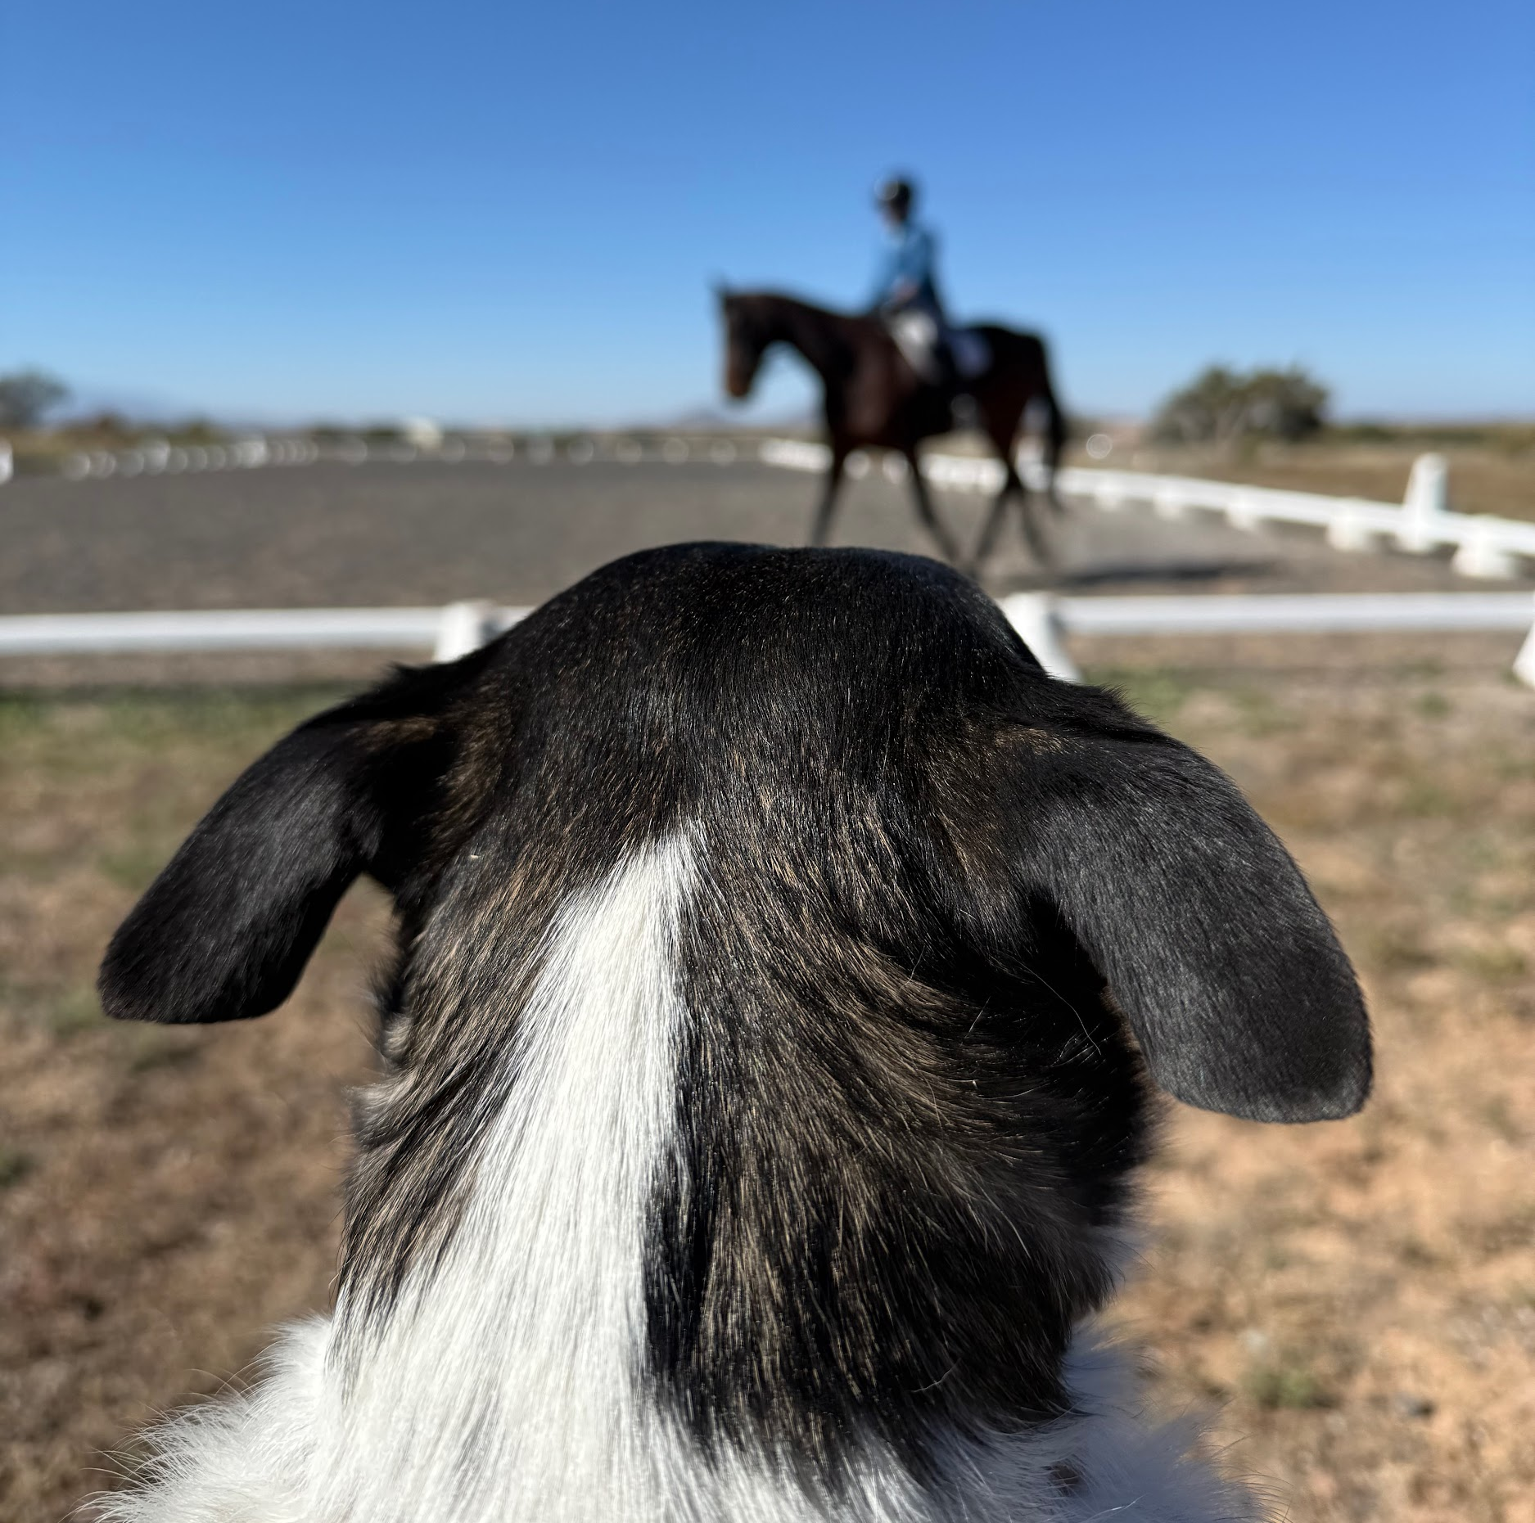
Finally, we addressed an issue we have in the medium and extended trot. When Z gets strong in the connection during mediums or extensions, any disruption, either from my hand or one that is self-inflicted, can cause him to lose balance and “bobble.” I had been trying short diagonals to help him gain confidence, but Bill proposed a different idea. He asked us to start a full diagonal in rising trot, asking for a medium trot with focus on uphill balance, engagement, and a light connection. At X, I sat the trot and pushed for the extended trot, keeping the same feel. With this exercise, Z stayed balanced and confident through the full diagonal with no “bobbles”!
Overall, this clinic was a wonderful experience that deepened both my understanding and my partnership with Z. I am grateful to Dressage4Kids for providing this scholarship opportunity and for supporting my continued dressage education. Z and I are inspired, with new tools to refine our work and continue progressing toward our goals.

